Siddaganga Institute of Technology, Tumakuru – 572103
(An Autonomous Institution, Affiliated to VTU, Belagavi & Recognized by AICTE, New Delhi)
2024 -2025


An
Activity Based Learning report
Digital Circuits and Computer Organization

Title: Combinational Digital Circuits

Submitted by
DHRUVA D - 1SI23CI013

Under the supervision of
Manjushree K

Name of student | USN | Marks
DHRUVA D | 1SI23CI013

Signature of In charge Faculty
- Introduction to Karnaugh Map (K-Map)
A Karnaugh Map (K-Map) is a graphical tool used to simplify Boolean expressions and minimize logic circuits. It organizes truth table values into a grid format, enabling easy identification of patterns for simplification.
- Key Points:
- Structure: A grid with 2^n cells, where n is the number of variables. Cells are labeled using Gray Code.
- Purpose: Simplify Boolean expressions by grouping adjacent 1s or 0s.
- Grouping Rules: Groups must be powers of 2 (1, 2, 4, etc.), and adjacent cells differ by one variable. Groups can wrap around the edges.
- Steps:
  - Populate the map with truth table values.
  - Group adjacent 1s.
  - Derive the simplified expression.
- Benefits:
- Reduces circuit complexity.
- Minimizes logic gates.
- Visual and systematic simplification.
K-Maps are commonly used in designing efficient combinational circuits.

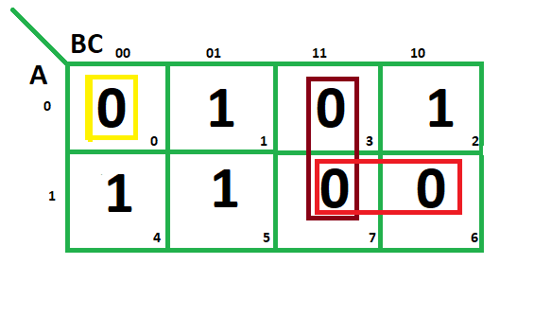

- Construction of Kmaps

How to Make a K-Map
A Karnaugh Map (K-Map) is constructed based on the number of variables in a Boolean function. Follow these steps:

1. Determine the Number of Variables
- The number of cells in the K-Map is 2^n, where n is the number of variables.
  - Example: 2 variables → 4 cells, 3 variables → 8 cells, 4 variables → 16 cells.

2. Draw the K-Map Grid
- Create a grid with rows and columns based on the number of variables:
  - 2 variables: 2×22 \times 22×2 grid.
  - 3 variables: 2×42 \times 42×4 grid.
  - 4 variables: 4×44 \times 44×4 grid.

3. Label Rows and Columns Using Gray Code
- Use Gray Code for labels to ensure that adjacent cells differ by only one bit.
  - Example for 2 variables:
    - Columns: 0, 1 (for B).
    - Rows: 0, 1 (for A).
  - Example for 3 variables:
    - Rows: 0, 1 (for A).
    - Columns: 00, 01, 11, 10 (for B,C).

4. Fill the K-Map
- Transfer truth table values into the K-Map based on the input combinations.
- Each cell represents one combination of the variables.

5. Group the Cells
- Group 1s (or 0s) into rectangles of size 1,2,4,8, etc.
- Groups must:
  - Contain powers of 2 cells.
  - Be as large as possible.
  - Wrap around edges if necessary.

6. Derive the Simplified Expression
- For each group:
  - Identify the variables that remain constant.
  - Write these variables as the simplified terms.

Example for 3 Variables (A,B,C):
- Truth Table:
  - A=0,B=0,C=0:Output = 1.
  - A=0,B=0,C=1: Output = 0, etc.
- K-Map:
  - Fill the grid with output values.
- Group 1s:
  - Simplify the expression (e.g., F=A+BC).
K-Maps are a systematic way to reduce Boolean expressions, making digital circuit design more efficient.

- Adders in Digital circuits
An Adder is a fundamental combinational circuit in digital electronics used to perform binary addition. There are two main types of adders:

- Half Adder
A Half Adder adds two single-bit binary numbers (A and B) and produces two outputs:
- Sum (S): Represents the binary sum of A and B. Formula: S=A⊕B (XOR operation).
- Carry (C): Represents the carry-out of the addition. Formula: C=A⋅B (AND operation).

Truth Table for Half Adder:
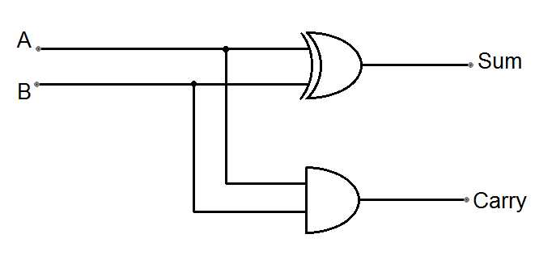
A | B | Sum (S) | Carry(C)
0 | 0 | 0 | 0
0 | 1 | 1 | 0
1 | 0 | 1 | 0
1 | 1 | 0 | 1
- Full Adder
A Full Adder adds three single-bit inputs (A, B and Cin) where Cin ​ is the carry-in from the previous stage. It produces two outputs:
- Sum (S): Formula: S=A⊕B⊕Cin (XOR operation).
- Carry (C): Formula: Cout=(A⋅B)+(Cin⋅(A⊕B))

Truth Table for Full Adder:
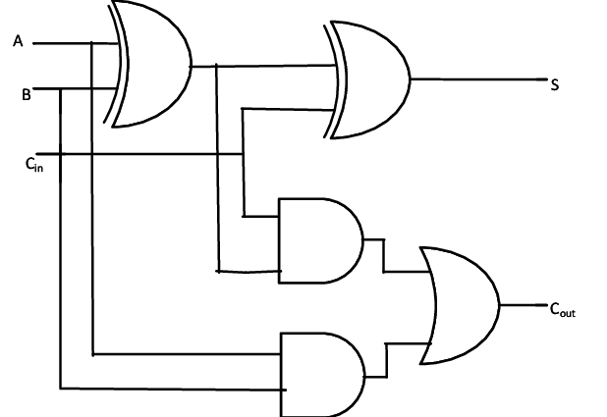
A |  | B | Cin​ | Sum (S) | Carry (C)
0 |  | 0 | 0 | 0 | 0
0 |  | 0 | 1 | 1 | 0
0 |  | 1 | 0 | 1 | 0
0 |  | 1 | 1 | 0 | 1
1 |  | 0 | 0 | 1 | 0
1 |  | 0 | 1 | 0 | 1
1 |  | 1 | 0 | 0 | 1
1 |  | 1 | 1 | 1 | 1

Cascading Adders
Multiple Full Adders can be connected to add multi-bit binary numbers. For n-bit numbers, n Full Adders are used, with the carry-out of one stage feeding the carry-in of the next.

- Applications of Adders
Used in Arithmetic Logic Units (ALUs) of processors.
Perform binary addition in digital systems.
Form the basis of other circuits like subtractors and multipliers.

- Subtractors and Multipliers
In digital electronics, subtractors and multipliers are essential combinational circuits used for arithmetic operations.

1. Subtractor
A subtractor is used to perform binary subtraction. There are two types of subtractors:
- Half Subtractor:
A half subtractor is a circuit that subtracts two single-bit binary numbers and provides two outputs: the difference and the borrow. The difference is obtained using an XOR operation, while the borrow is determined using an AND and NOT operation. It is used for basic single-bit subtraction without considering a borrow from the previous stage.
- Full Subtractor:
A full subtractor extends the functionality of the half subtractor by including a borrow input. It can subtract three inputs: two binary numbers and a borrow from a previous stage. The outputs are the difference and the borrow. Full subtractors are used in multi-bit binary subtraction by cascading them for successive bits.

2. Multiplier
A multiplier is a combinational circuit that performs binary multiplication. It operates on the principle of repeated addition and shifting:
- Each bit of the multiplier is multiplied with the multiplicand.
- The partial products are generated for each bit of the multiplier.
- These partial products are shifted left based on the position of the bit in the multiplier.
- Finally, all the partial products are summed to produce the final product.
Multipliers are used in digital signal processing, image processing, and arithmetic operations in processors. Multi-bit multipliers are implemented using advanced algorithms like array multiplication, booth multiplication, or Wallace tree multiplication for speed optimization.

- Applications
- Subtractors: Used in ALUs, digital comparators, and circuits that perform binary division.
- Multipliers: Used in processors, graphics systems, neural networks, and digital signal processing systems.

- Decoders
A decoder is a combinational circuit that converts binary input into a unique output line. It has n input lines and 2^n output lines, where only one output is active at a time based on the binary input.
- Key Features:
- Functionality: Decodes binary data into a specific output line.
- Inputs and Outputs: For n inputs, it generates 2^n unique outputs.
- Enable Pin: Often includes an enable input to control the operation.
- Types of Decoders:
- 2-to-4 Decoder: 2 inputs, 4 outputs.
- 3-to-8 Decoder: 3 inputs, 8 outputs.
- Larger decoders are formed by cascading smaller ones.
- Applications:
- Data Routing: Used to select specific memory locations in RAM.
- Instruction Decoding: Converts binary instructions into control signals in processors.
- Display Systems: Drives seven-segment displays in digital devices

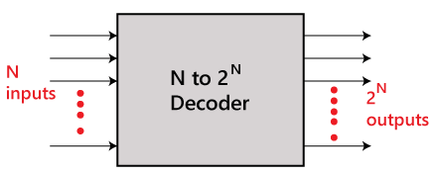

Implementation of Higher-Order Decoders Using Lower-Order Decoders
Higher-order decoders can be constructed by combining multiple lower-order decoders with additional enable signals to control which decoder is active. This method modularizes the design and simplifies the implementation of large-scale decoders.

- General Approach:
- Inputs Division: Split the inputs into two groups:
  - The selection group to control the enable signals of the lower-order decoders.
  - The data group connected directly to the inputs of the lower-order decoders.
- Enable Logic: Use the selection inputs to activate one of the lower-order decoders at a time. This ensures only one decoder produces an active output.
- Output Combination: Combine all outputs from the lower-order decoders to form the higher-order decoder's final outputs.

Example: 3-to-8 Decoder Using 2-to-4 Decoders
To construct a 3-to-8 decoder using 2-to-4 decoders, follow these steps:
- Inputs: A,B,C
  - A is the selection input (controls enable signals).
  - B,C are the data inputs (connected to the 2-to-4 decoders).
- Components:
  - Two 2-to-4 decoders with enable inputs.
- Connections:
  - Connect B and C to the inputs of both 2-to-4 decoders.
  - Use A to enable only one decoder at a time:
    - When A=0A = 0A=0, enable the first decoder (outputs Y0Y​ to Y3Y​).
    - When A=1A = 1A=1, enable the second decoder (outputs Y4Y to Y7Y​).
- Output Mapping:
  - The outputs of the first decoder correspond to Y0,Y1,Y2,Y3​.
  - The outputs of the second decoder correspond to Y4,Y5,Y6,Y7​.

- Generalization:
For an n-to-2^n decoder:
- Divide n inputs into mmm data inputs and (n−m) selection inputs.
- Use 2(n−m) lower-order m-to-2^m decoders.
- Control the enable signals of the decoders using selection inputs to ensure only one decoder is active at a time.

- Multiplexer in Digital Circuits
A Multiplexer (MUX) is a combinational circuit that selects one of several input signals and forwards the selected input to a single output line based on control signals. It is also called a data selector.

- Key Features:
- Inputs: A multiplexer has 2n2^n2n data inputs (D0,D1,...,D2n−1) and n selection lines (S0,S1,...,Sn−1​).
- Output: A single output line that carries the selected data input.
- Selection Lines: Determine which input is passed to the output. The selection lines form a binary code corresponding to the active input.

- Working Principle:
- The selection lines control the MUX by acting as a binary index.
- For a given combination of selection line values, one specific input line is connected to the output.
- The circuit ensures only one data input is routed to the output at any time.

- Types of Multiplexers:
- 2-to-1 Multiplexer:
  - 2 inputs, 1 selection line, and 1 output.
  - Output formula: Y=S⋅D1+S⋅D0​.
- 4-to-1 Multiplexer:
  - 4 inputs, 2 selection lines, and 1 output.
  - Output formula: Y=S1S0D0+S1S0D1+S1S0D2+S1S0D3​.
- 8-to-1 Multiplexer:
  - 8 inputs, 3 selection lines, and 1 output.

- 16-to-1 Multiplexer:
  - 16 inputs, 4 selection lines, and 1 output.

- Implementation of Larger MUX Using Smaller MUX:
- Larger multiplexers can be built using smaller multiplexers and additional selection lines.
- For example, a 4-to-1 MUX can be constructed using two 2-to-1 MUXes and one additional 2-to-1 MUX as a selector.

- Applications of Multiplexers:
- Data Routing: Selects one of several data sources for communication.
- Arithmetic and Logic Circuits: Used in ALUs to select operations or inputs.
- Communication Systems: Combines multiple data signals for transmission.
- Memory Addressing: Selects specific memory locations for read/write operations.

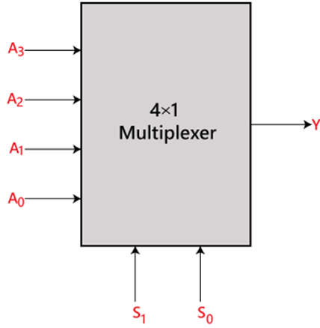

Implementation Higher-Order Mux Using Lower-Order Mux
Higher-order multiplexers can be implemented by combining multiple smaller multiplexers and utilizing additional selection logic. This approach helps in building larger multiplexers from simpler ones, making the design process more modular.

- Basic Strategy:
For an 2^n-to-1 multiplexer:
- Split the 2^n inputs into smaller groups, each handled by a lower-order multiplexer.
- Use an additional multiplexer to combine the outputs of the lower-order multiplexers.
- The selection lines are divided into two sets:
  - One set controls the individual lower-order multiplexers.
  - The second set manages the final multiplexer.

- Example: 4-to-1 Multiplexer Using 2-to-1 Multiplexers
- Inputs: The 4 data inputs D0,D1,D2,D3​ and selection lines S0S​ and S1S​.
- Components:
  - Two 2-to-1 multiplexers in the first stage.
  - One 2-to-1 multiplexer in the final stage.
- Connections:
  - Feed inputs D0​ and D1​ into the first 2-to-1 multiplexer, controlled by S0​.
  - Feed inputs D2 and D3​ into the second 2-to-1 multiplexer, also controlled by S0.
  - The outputs of these two multiplexers are fed into the third 2-to-1 multiplexer, which is controlled by S1.

- Function:
  - The first selection line, S0S​, chooses between the pairs of inputs (D0,D1or D2,D3​).
  - The second selection line, S1S​, selects the final output from the first-stage multiplexers.

- General Approach for Larger Multiplexers:
For a general 2^n-to-1 multiplexer using smaller 2^m-to-1 multiplexers (m<n):
- Divide the 2^n inputs into 2^{n-m} groups, where each group has 2^m inputs.
- Use 2^{n-m} multiplexers of size 2^m-to-1 for the first stage.
- Use a final multiplexer to combine the outputs of these 2^{n-m} multiplexers.
- Split the selection lines:
  - Assign m selection lines to control the smaller multiplexers.
  - Use the remaining n−m selection lines to control the final multiplexer.

Applications:
- Efficient construction of large multiplexers by reusing smaller components.
- Simplifies the design of systems such as data selectors, arithmetic logic units (ALUs), and communication circuits.

Thankyou

